Using Samba through Stunnel
What is Stunnel 2
Configuring the server 3
Configuring the client 3
Windows loopback devices 3
Installing Stunnel 3
Map the network drives 4
Performance testing 4

What is Stunnel
The blurb from stunnel.org describes it this way:
"Stunnel is a program that allows you to encrypt arbitrary TCP connections inside SSL (Secure Sockets Layer) available on both Unix and Windows. Stunnel can allow you to secure non-SSL aware daemons and protocols (like POP, IMAP, LDAP, etc) by having Stunnel provide the encryption, requiring no changes to the daemon's code."
Following is a quick introduction to how Stunnel works.
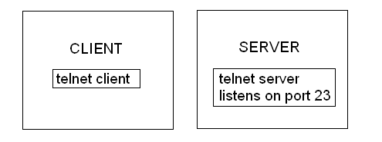
Figure 1: Normal telnet connection
Figure 1 shows the normal setup for a telnet server and client. The server listens on TCP port 23 for incoming connections. The client connects directly to the server using its IP or hostname:
$ telnet SERVER
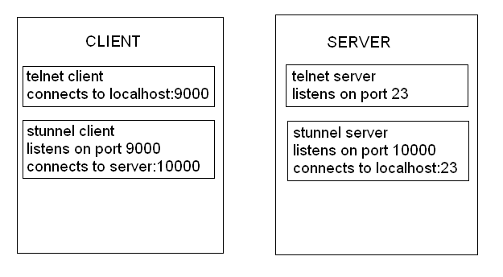
Figure 2: Using Stunnel to secure telnet
Figure 2 shows how to use Stunnel to encrypt telnet. The Stunnel server is configured to listen on an arbitrary available port. In this case it is port 10000. The server is then instructed to forward anything from port 10000 to port 23. The client configuration is quite similar. In the demo case it is configured to listen on port 9000 and forward things to the server's port 10000.
So to use the encrypted tunnel the client would actually telnet to port 9000 on itself:
$ telnet localhost 9000
What happens then is this:
- The client application (telnet) connects to port 9000 on itself.
- Stunnel is listening on port 9000 and receives the first packet from the client application.
- Stunnel on the client initiates a connection with Stunnel on port 10000 on the server. The initiation includes a negotiation of what encryption scheme to use.
- Stunnel on the client encrypts the packet from the telnet client and forwards it to port 10000 on the server.
- Stunnel on the server decrypts the packet and forwards it to the telnet daemon that is listening on port 23.

Configuring the server
The latest versions of zlib, OpenSSL and Stunnel were downloaded, compiled and packaged for AIX. The install process creates a dummy certificate that is used for the encryption. The configuration file looks like this:
cert = /etc/stunnel/stunnel/stunnel.pem
compression = zlib
client = no
debug = 6
pid = /etc/stunnel/stunnel/stunnel.pid

; Some performance tunings
socket = l:TCP_NODELAY=1
socket = r:TCP_NODELAY=1

[tax178]
accept=10000
connect=139

Configuring the client

Windows loopback devices
It is not possible to change the port to use for accessing file shares in Windows. Everything has to go over port 139 and that port is restricted so it is impossible to use Stunnel with the standard loopback device. To get around this we have to add additional loopback devices for each remote host we want to access.

Do not do this on a machine that is also used for OEM. OEM's change manager has a problem when used on a machine with multiple NICs.

Adding an extra loopback device:
- System->Control Panel->Add Hardware
- Yes, Hardware is already connected
- Add a new hardware device (at bottom of list)
- Install the hardware that I manually select
- Network adapters
- Microsoft , Microsoft Loopback Adapter

Configure the new device:
- Un-check the "File and Printer Sharing for Microsoft Networks" option.
- Select "Internet Protocol (TCP/IP) and click properties.
- Click on "Use the following IP address" and set IP address to 169.254.0.X (where X is a number from 1 to 254).
- Click the "Advanced..." button and select the "WINS" pane.
- Select "Disable NetBIOS over TCP/IP".

We currently have three servers that provide various Samba shares so we have to configure three loopback devices.

Installing Stunnel
Installing Stunnel is very simple:
- Create a directory (C:\stunnel)
- Copy the Stunnel executable and two SSL DLL files to the directory:
stunnel-4.11.exe
libeay32.dll
libssl32.dll
- Create the stunnel.conf file:
client=yes
taskbar=no
debug=6
output=c:\stunnel\stunnel.log
[tax183smb]
accept=169.254.0.1:139
connect=10.0.89.183:10000
[tax186asmb]
accept=169.254.0.2:139
connect=10.0.88.186:10000
[tax187asmb]
accept=169.254.0.3:139
connect=10.0.88.187:10000
- Go to the command prompt or use Start->Run... and execute the following command to install Stunnel as a service:
c:\stunnel\stunnel-4.11.exe -install

Map the network drives
Network drives can now be accessed through the secure tunnel by mapping drives to the loopback devices. For example the universal M: drive will have to be mapped to:
\\169.254.0.1\image.nfs
instead of:
\\tax183\image.nfs

Performance testing
I used a directory with around 2,600 files and sub-directories for my testing. The directory contained the un-packed source files for OpenSSL 0.9.7g and had a mix of large and small files. The total size of the directory was around 42.8MB.

The first test client was a 3GHz P4 with 1GB RAM (my PC). When using Stunnel it took on average 75 seconds to copy the test directory to the local C: drive. Without Stunnel it took on average 42 seconds.
The second test client was a 1.8GHz P4 with 1GB RAM. When using Stunnel it took on average 147 seconds to copy the test directory to the local C: drive. Without Stunnel it took on average 74 seconds.
The total number of bytes transferred over the wire increased by about 8% when Stunnel was used.
The total CPU utilization on the server went up by about 40-50% when the Samba shares were accessed through Stunnel.

