Run stunnel.exe from the config folder:
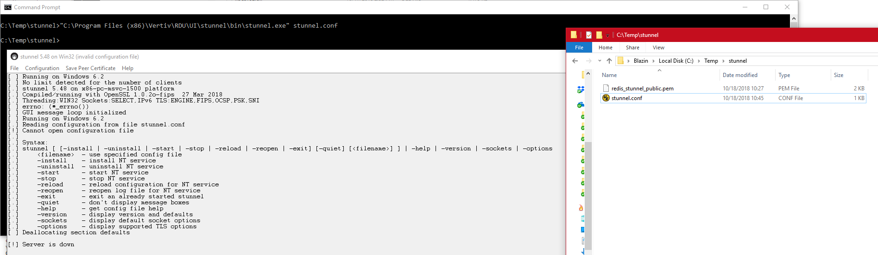

Run stunnel.exe from bin folder
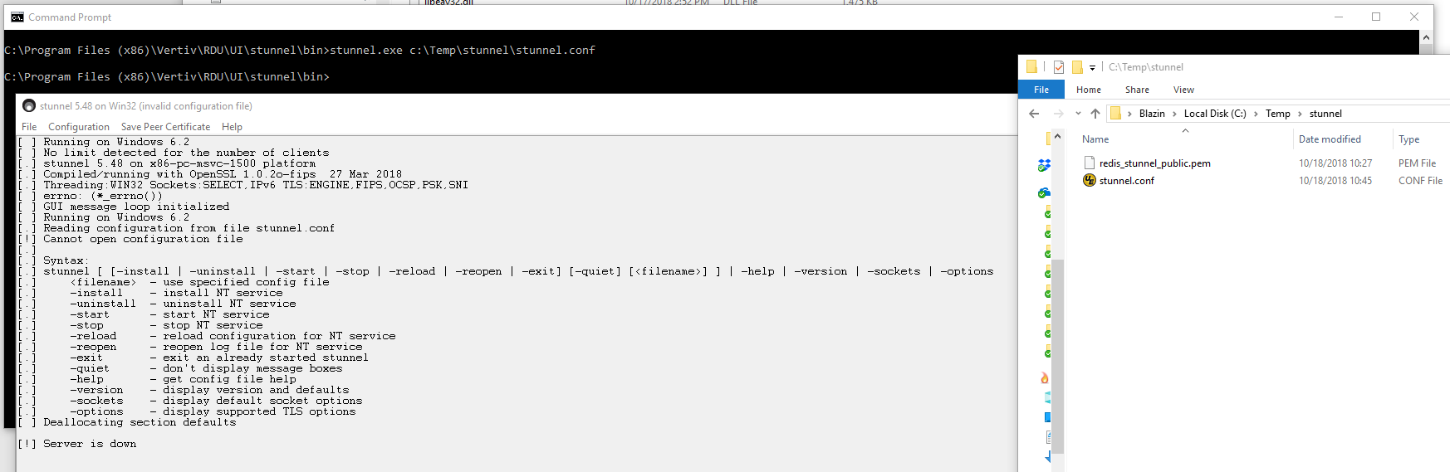

My conf file:
[redisClient]
client = yes
accept = 127.0.0.1:6379
connect = 10.0.0.34:6379
verifyChain = no
CAfile = redis_stunnel_public.pem
checkHost = 10.0.0.34
verifyPeer = yes
OCSPaia = no

